Final Experimentation Report
Pakistan-adapted reinforcement learning experiments for long-horizon crop management

Abstract
This report consolidates the finalized experimentation evidence for the thesis on cost-aware reinforcement learning for agricultural resource allocation in a Pakistan-adapted CyclesGym stack. It integrates a 113-run core matrix and a 42-run ablation suite into a single thesis-ready narrative. The strongest grouped result in fertilization was observed for A2C | nonadaptive | fixed_weather | years=5000, which reached a mean primary metric of 779,267.35. The strongest grouped result in hierarchical crop planning was PPO | fixed_weather | guarded_rerun, with a mean deterministic return of 1,861,223.08, while the best overall single run was 081_crop_planning_hierarchical_ppo_fixed_weather_seed_1_profile_pakistan_baseline at 1,971,988.25. The ablation suite shows a clear interaction between entropy and environmental stochasticity: zero entropy was strongest in fixed weather, whereas entropy 0.01 improved random-weather deterministic return by 44,787.79 with p=0.0106. Blocked-penalty shaping should be interpreted descriptively rather than inferentially because it uses single-seed comparisons, but every recorded compliance-rate value remained 1.0, implying reward reshaping rather than constraint enforcement. Across the nutrient-cost ablation, weight 1.0 remained the safest default despite a marginal random-weather edge for 1.2.

1. Experimental objectives and evidence base
The purpose of this report is to convert the available experimentation artifacts into a final, academically coherent results chapter for the thesis. The report is grounded in the thesis framing from the reference LaTeX archive and in the audited grouped CSV packs that back the antigravity report. The empirical evidence consists of 75 fertilization runs and 38 crop-planning runs in the core matrix, together with three focused ablation branches covering entropy, blocked-penalty shaping, and nutrient-cost weighting.
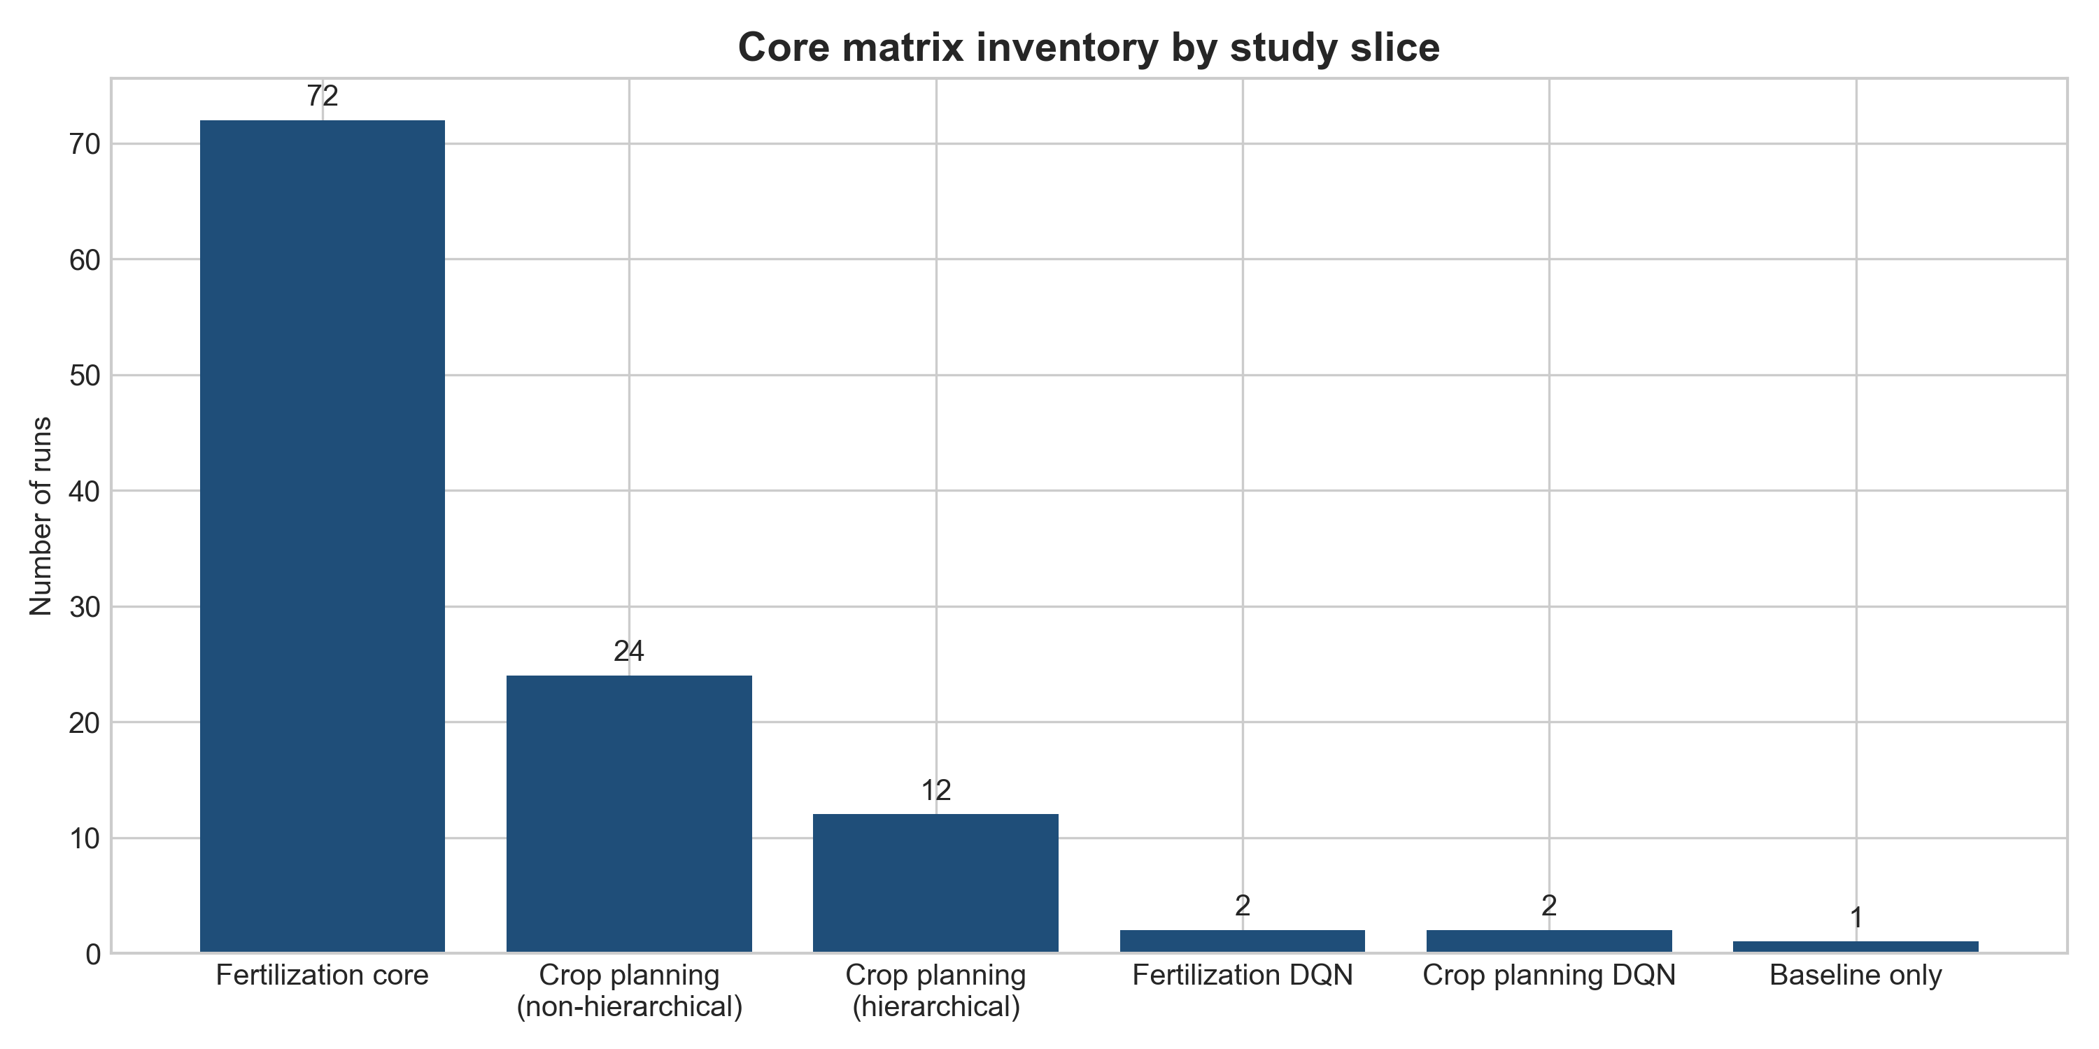
Figure 1. Inventory of the completed core matrix by study slice.
Table 1. Distribution of the completed core matrix.
Report group | Runs
Fertilization core | 72
Crop planning (non-hierarchical) | 24
Crop planning (hierarchical guarded reruns) | 12
Fertilization DQN reruns | 2
Crop planning DQN reruns | 2
Baseline only | 1

2. Experimental protocol
The experimentation stack evaluates three decision layers: weekly fertilization control, seasonal crop planning, and a hierarchical formulation that combines yearly crop choice with within-season nutrient actions. The underlying thesis framing is Pakistan-oriented and cost-aware: weather, soil, and price inputs are localized, but the active experimental configuration remains simulation-based and tied to the currently stabilized maize-soy setup. PPO and A2C are the main algorithms; DQN is included only as a descriptive reference rather than a seed-balanced competitor.
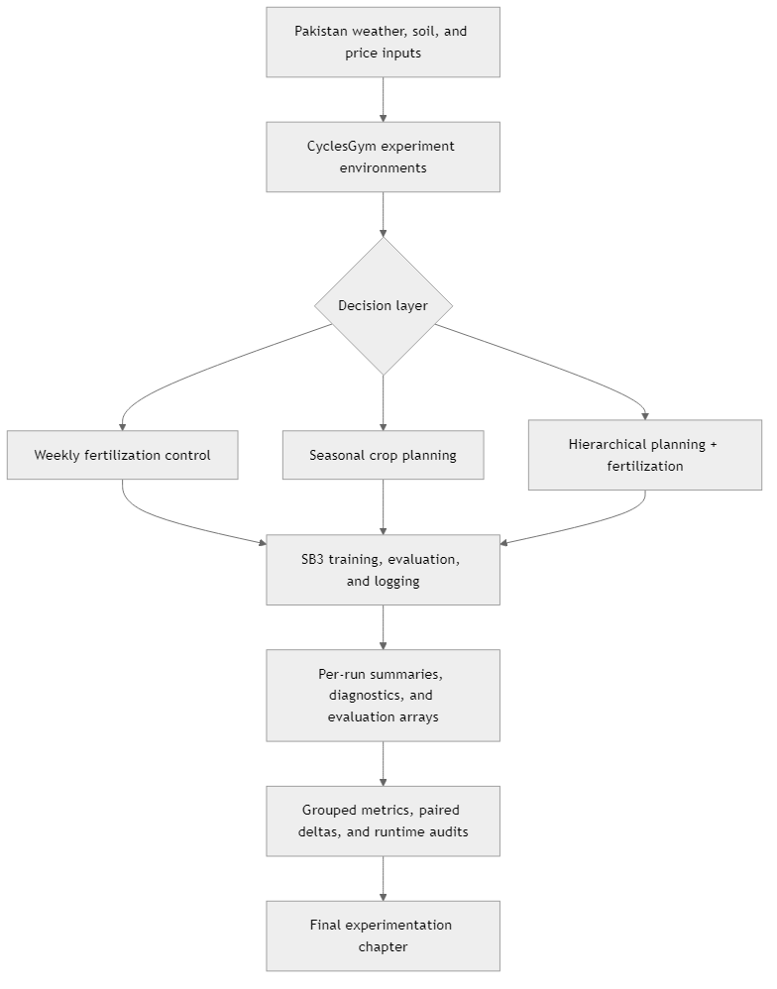
Figure 2. End-to-end experiment workflow from localized inputs to thesis-ready grouped metrics.
Figure 3. Two-timescale decision structure used by the hierarchical crop-planning formulation.
Metrics were interpreted in layers. Grouped primary metrics were used for ranking, deterministic and stochastic returns for behavioral interpretation, and runtime and compliance outputs for operational context. This layered reading is important because a thesis defense requires more than a leaderboard; it requires a clear explanation of how the policy behaves and under what constraints.

3. Core matrix results
The core matrix shows that the strongest absolute returns came from hierarchical crop-planning reruns, whereas the strongest grouped fertilization result remained an A2C configuration under deterministic weather and a long training horizon. This split matters because it shows that the best-performing method depends on both the decision layer and the degree of environmental stochasticity.
Table 2. Key grouped winners and best single runs extracted from the core matrix.
study_slice | configuration | metric | value | interval
Fertilization grouped winner | A2C | nonadaptive | fixed_weather | years=5000 | deterministic_return | 779,267.35 | [727,686.53, 830,848.18]
Fertilization best single run | 017_fertilization_ppo_adaptive_fixed_weather_years_3000_seed_1 | deterministic_return | 791,255.50 | single run
Non-hierarchical crop planning grouped winner | PPO | nonadaptive | fixed_weather | eval_det_mean_reward | 21,230.91 | [15,225.61, 27,236.22]
Non-hierarchical crop planning best single run | 103_crop_planning_a2c_adaptive_fixed_weather_seed_2 | eval_det_mean_reward | 23,601.588 | single run
Hierarchical grouped winner | PPO | fixed_weather | guarded_rerun | deterministic_return | 1,861,223.08 | [1,512,430.79, 2,210,015.38]
Overall best single run | 081_crop_planning_hierarchical_ppo_fixed_weather_seed_1_profile_pakistan_baseline | deterministic_return | 1,971,988.25 | single run

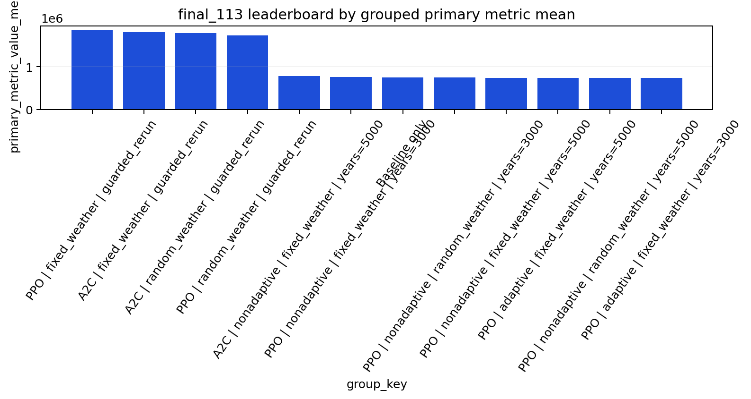
Figure 4. Grouped leaderboard from the Final 113 core matrix.
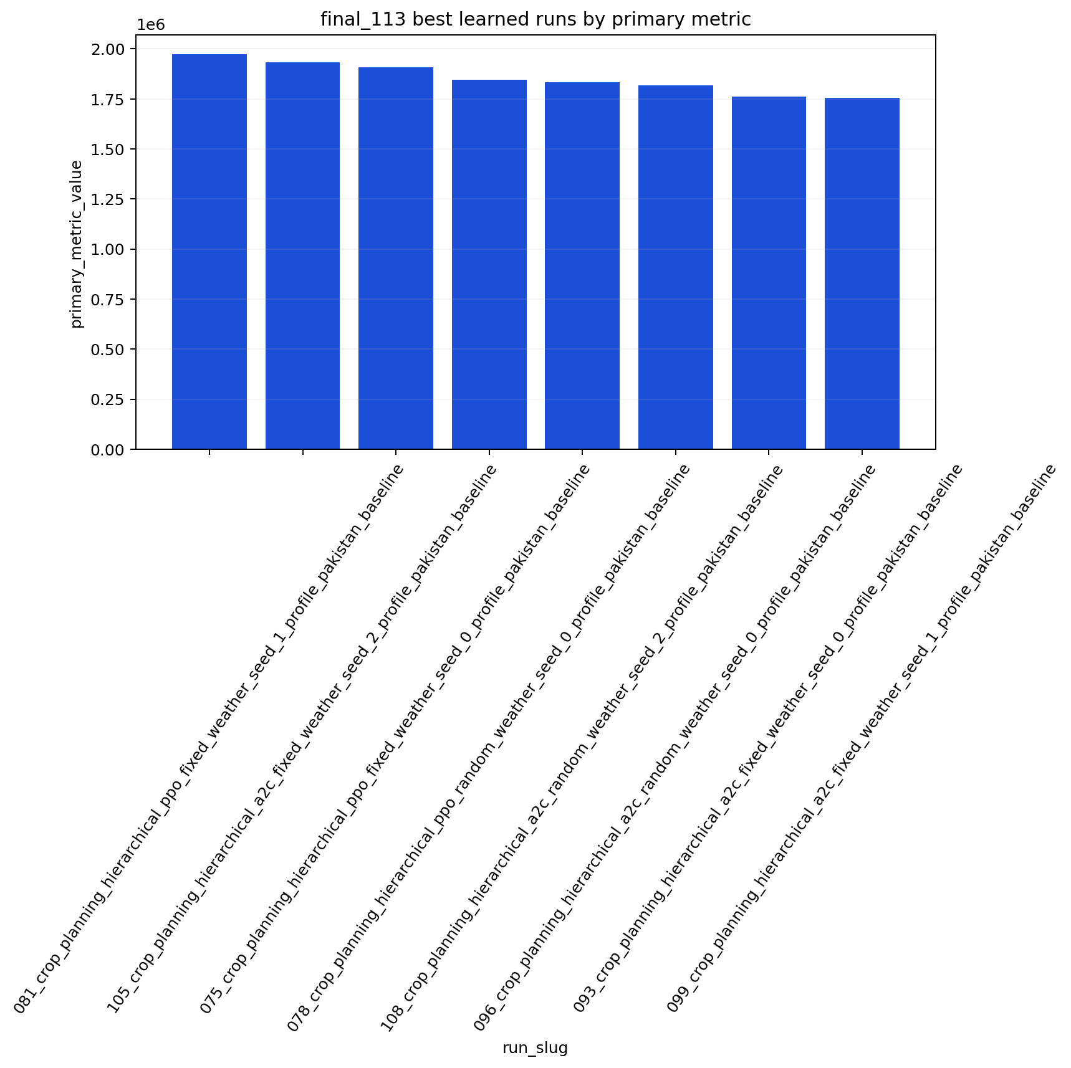
Figure 5. Best single-run outcomes in the core matrix, dominated by hierarchical crop-planning reruns.

3.1 Fertilization
The strongest grouped fertilization result was A2C | nonadaptive | fixed_weather | years=5000, which achieved a mean deterministic return of 779,267.35 with a 95% interval of [727,686.53, 830,848.18] across three seeds. The strongest single fertilization run was 017_fertilization_ppo_adaptive_fixed_weather_years_3000_seed_1 at 791,255.50. Substantively, this suggests that A2C remains competitive when the environment is deterministic and the budget is long, while PPO can still produce seed-level peaks under shorter fixed-weather configurations.

3.2 Non-hierarchical crop planning
For non-hierarchical crop planning, the strongest grouped result was PPO | nonadaptive | fixed_weather with a mean evaluation reward of 21,230.91. The strongest single non-hierarchical run was 103_crop_planning_a2c_adaptive_fixed_weather_seed_2 at 23,601.588. This ranking favors PPO for grouped stability, but it also shows that A2C can still discover favorable single-seed trajectories. The correct interpretation is therefore not that one method dominates everywhere, but that PPO offers the stronger default for repeatable non-hierarchical crop-planning performance.

3.3 Hierarchical crop planning and runtime tradeoffs
The strongest grouped hierarchical result was PPO | fixed_weather | guarded_rerun, which reached 1,861,223.08 with a 95% interval of [1,512,430.79, 2,210,015.38]. The best overall run in the entire evidence pack was 081_crop_planning_hierarchical_ppo_fixed_weather_seed_1_profile_pakistan_baseline at 1,971,988.25. These results indicate that once yearly crop choice is coupled to within-season fertilization, the value of hierarchical structure is large enough to dominate the experiment leaderboard. The tradeoff is computational: hierarchical reruns are materially slower than non-hierarchical crop-planning jobs and fertilization runs.
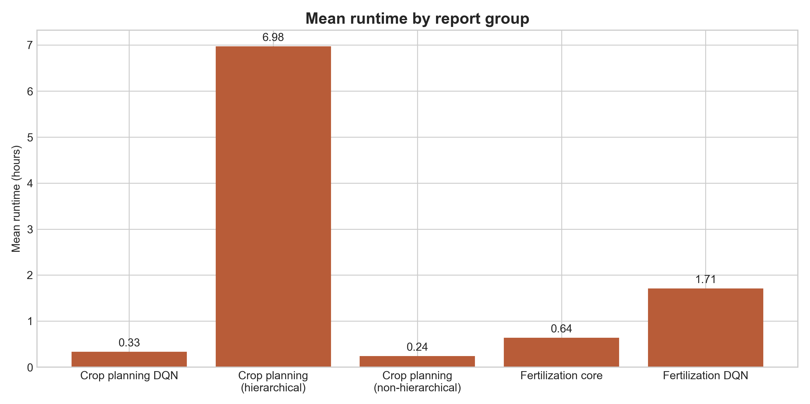
Figure 6. Mean runtime by report group, showing the heavier cost of hierarchical reruns.
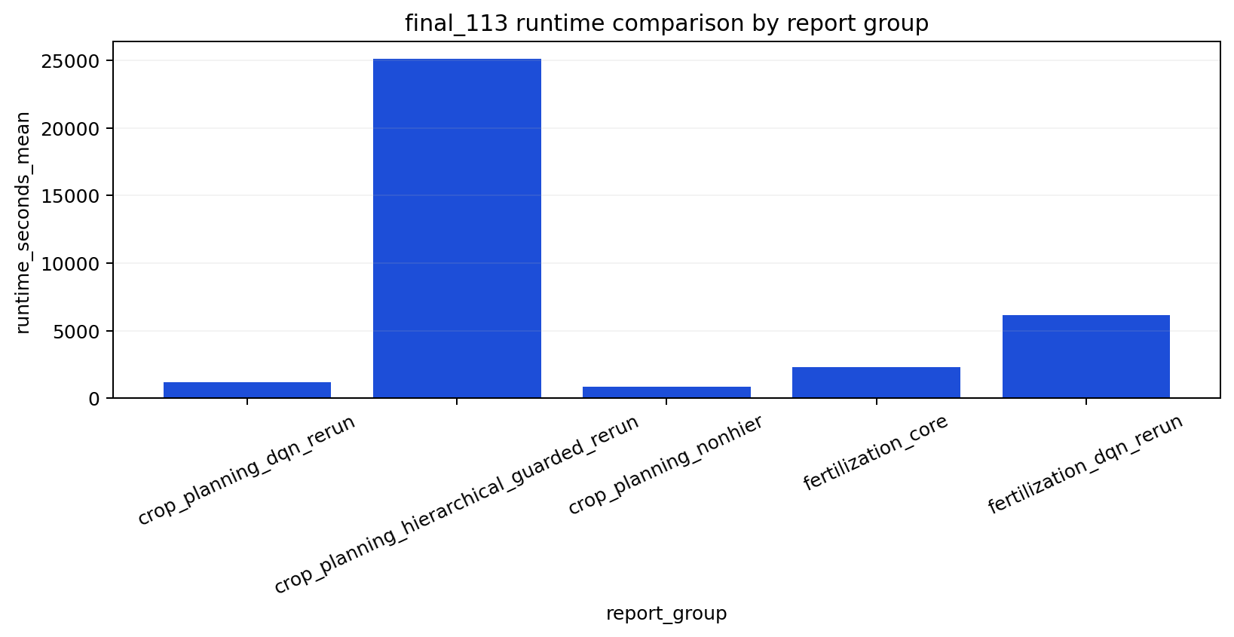
Figure 7. Distributional runtime comparison from the core matrix export pack.

4. Ablation results
The 42-run ablation suite should be read as a parameter-isolation study rather than as a second leaderboard. It answers three narrower questions: how much exploration pressure is needed, whether blocked-penalty shaping adds value beyond existing guards, and what nutrient-cost weight behaves most safely across weather regimes.
Table 3. High-level conclusions from the ablation suite.
ablation_point | finding | evidence
Entropy coefficient | Entropy 0.00 was strongest in fixed weather, whereas entropy 0.01 was strongest in random weather. | Fixed weather mean 738,110.27; random weather mean 740,758.90; paired random-weather delta 44,787.79 with p=0.0106.
Blocked-penalty shaping | The shaping term benefited A2C but hurt PPO, while compliance stayed perfectly saturated. | All 180 recorded compliance-rate values were 1.0; A2C fixed-weather best penalty 0.02; PPO fixed-weather best penalty 0.00.
Nutrient cost weight | Cost weight 1.0 remained the best fixed-weather default; 1.2 was only marginally strongest in random weather. | Fixed weather best mean 793,406.94 at weight 1.0; random weather best mean 735,830.31 at weight 1.2; random-weather 1.2 vs 1.0 delta 1,087.04 with p=0.8897.

4.1 Entropy coefficient
In fixed weather, the best grouped entropy setting was ent_coef=0.00 with a mean primary metric of 738,110.27. In random weather, the best grouped setting was ent_coef=0.01 with a mean of 740,758.90. The paired random-weather deterministic-return delta for ent_coef 0.01 relative to 0.00 was 44,787.79 with p=0.0106. This is the clearest inferential result in the ablation pack: entropy hurts convergence in deterministic regimes but becomes helpful once weather uncertainty is reintroduced.
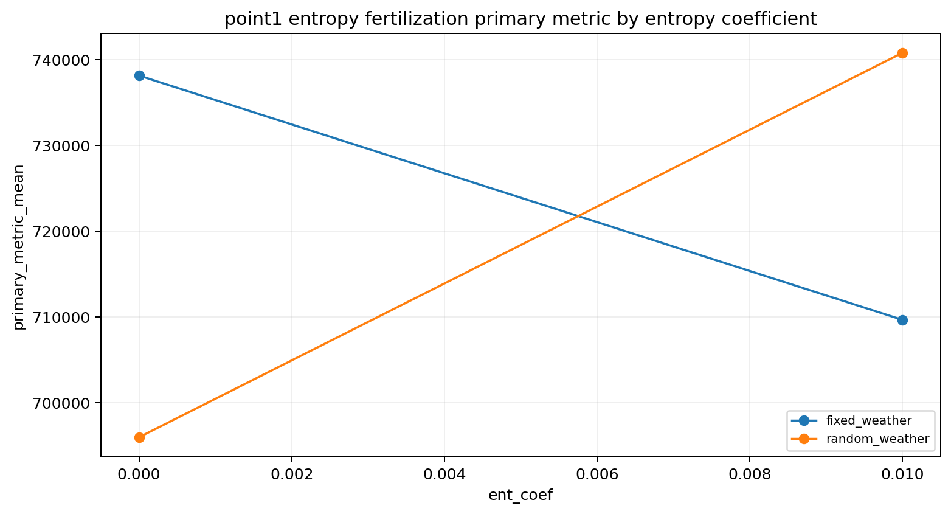
Figure 8. Entropy ablation showing the reversal between fixed and random weather.

4.2 Blocked-penalty shaping
The blocked-penalty ablation is descriptive because each configuration is represented by a single seed. Its most defensible finding is not the exact size of the return change, but the mechanism behind it: every recorded season-window compliance value remained 1.0, so the penalty did not improve rule adherence because adherence was already saturated. Instead, it changed the reward landscape. In A2C, moderate or strong penalty values improved the deterministic return. In PPO, the zero-penalty configuration remained best under both weather regimes.
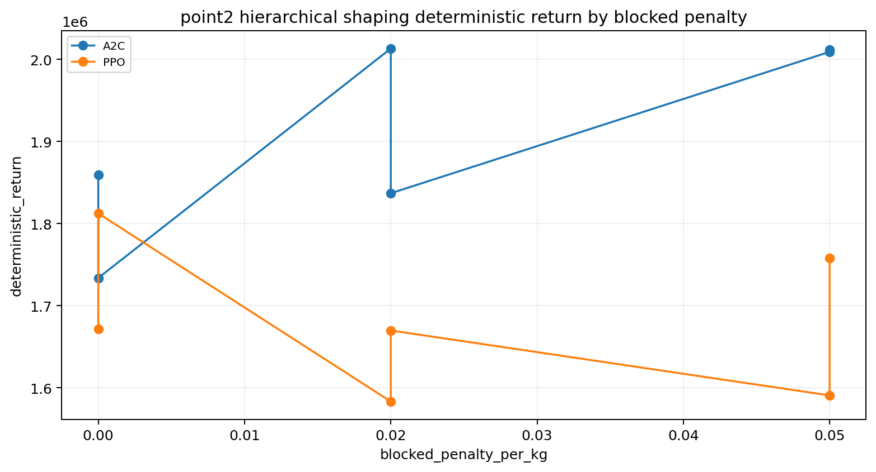
Figure 9. Deterministic-return comparison across blocked-penalty settings.
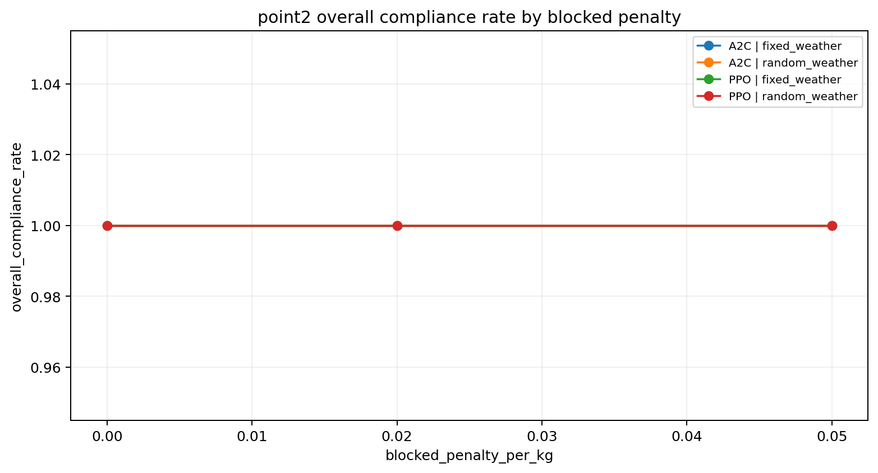
Figure 10. Compliance remained saturated across blocked-penalty settings.

4.3 Nutrient-cost weight
The best fixed-weather cost weight was 1.0, which achieved a mean primary metric of 793,406.94. In random weather, the highest grouped mean was observed at weight 1.2, but the margin over weight 1.0 was only 1,087.04 and was not statistically persuasive (p=0.8897). By contrast, under fixed weather the drop from 1.0 to 0.8 was 86,083.67. The academically careful conclusion is therefore that weight 1.0 remains the safest thesis default, while 1.2 may be explored in random weather if a slightly more conservative nutrient policy is desired.
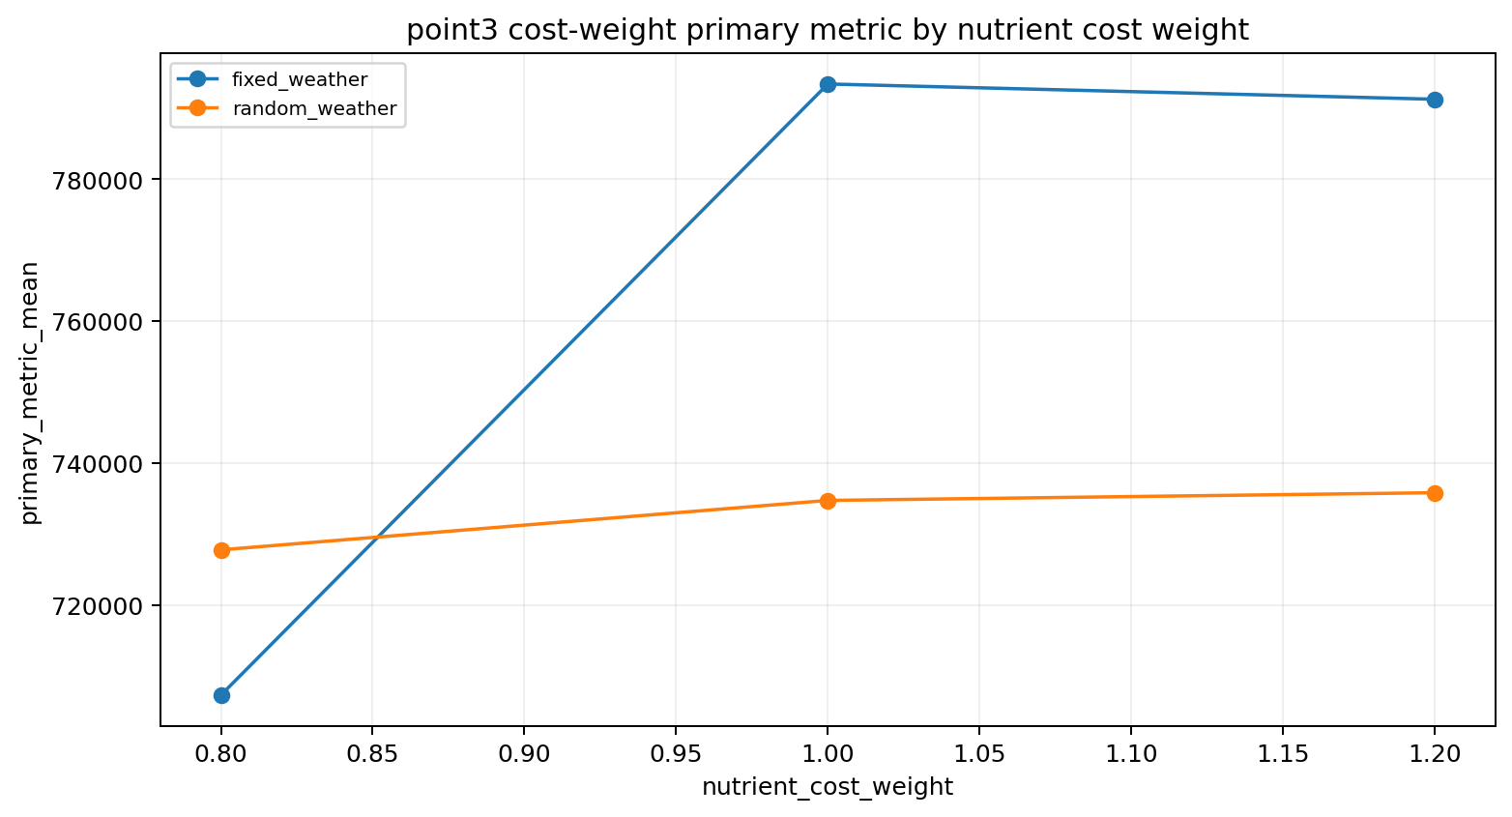
Figure 11. Grouped nutrient-cost-weight performance under fixed and random weather.
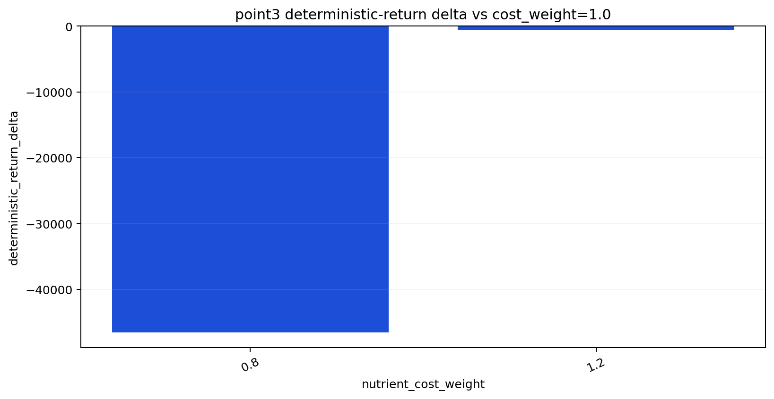
Figure 12. Paired delta view for the nutrient-cost-weight ablation.

5. Behavioral diagnostics
Grouped means explain which settings won, but the per-run diagnostics explain how those wins were realized. The extracted diagnostics show that the learning curves in successful runs become progressively smoother, that nutrient application is not uniformly distributed across the season, and that the hierarchical policies produce legible crop-decision traces. These properties matter because they make the experimentation chapter more interpretable than a pure return table.
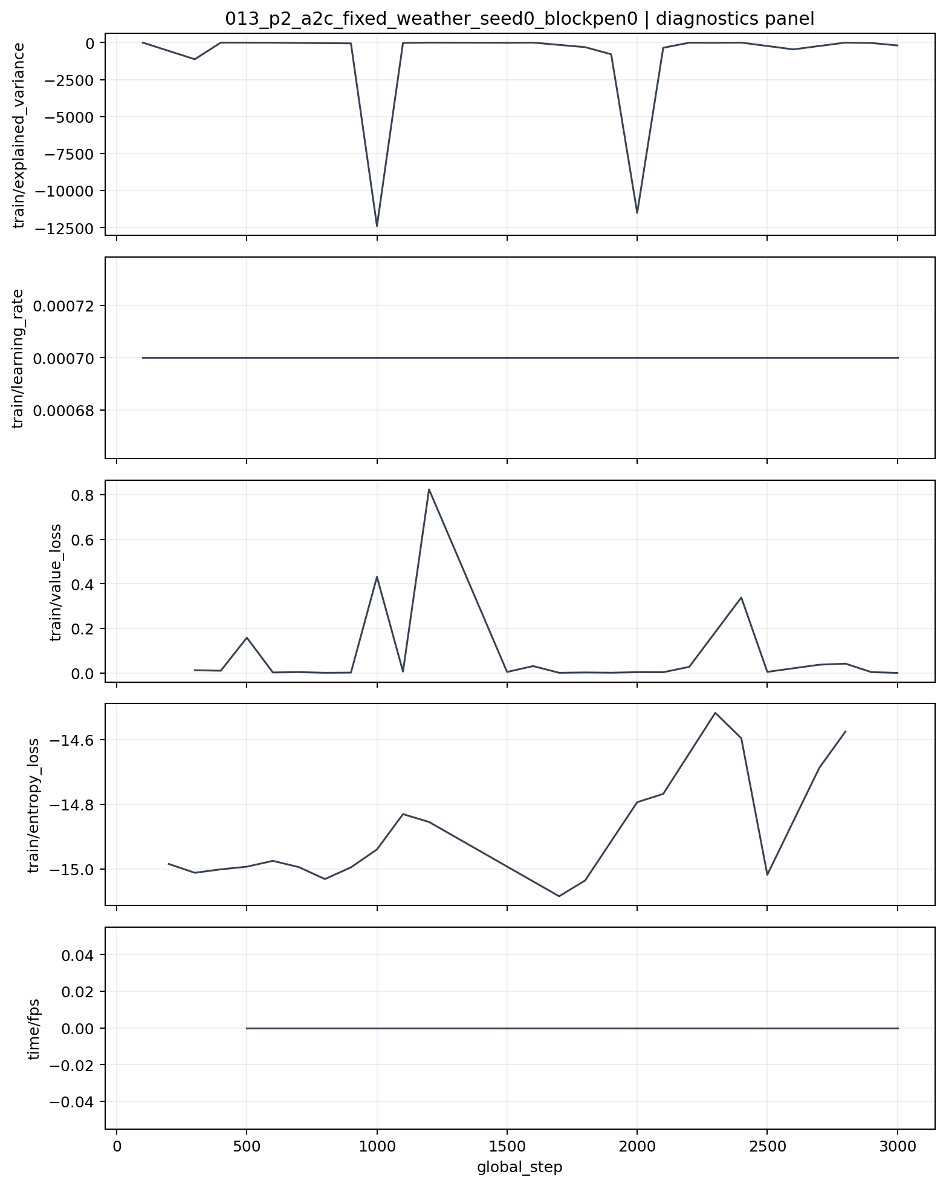
Figure 13. Representative training diagnostics from the blocked-penalty study.
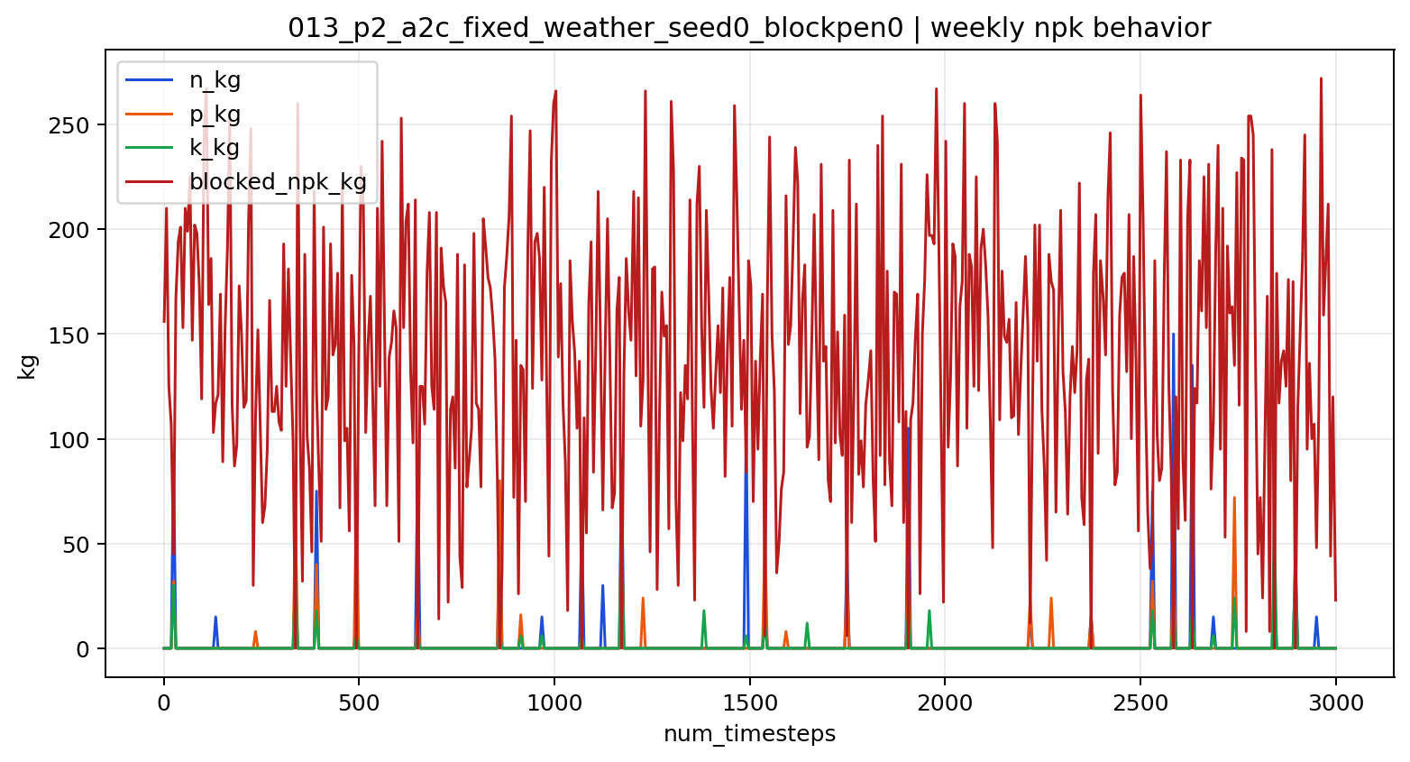
Figure 14. Weekly NPK behavior from a representative hierarchical run.
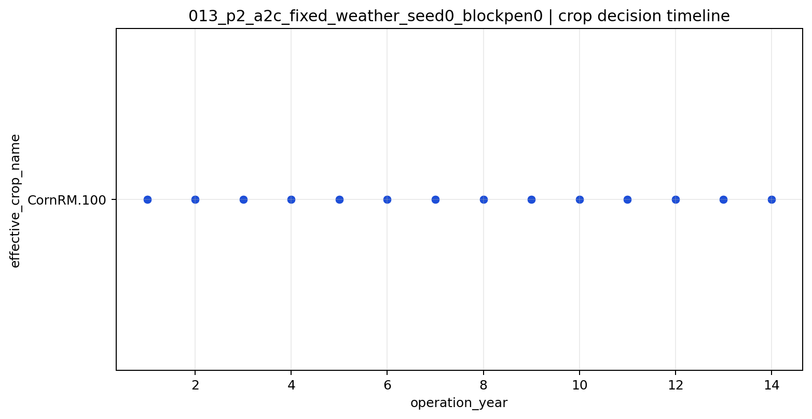
Figure 15. Crop-decision timeline illustrating the policy's yearly planning structure.

6. Discussion and validity boundaries
Three conclusions can be defended cleanly from this evidence pack. First, hierarchical crop planning produces the strongest absolute returns. Second, fertilization behavior is method-sensitive: A2C is highly competitive in deterministic fixed-weather settings, while PPO remains the more robust general choice once broader stochasticity and hierarchy are introduced. Third, the best hyperparameters are regime-dependent: entropy and cost weighting cannot be set intelligently without considering weather uncertainty.
- Simulation is the evaluation medium throughout; none of the conclusions should be presented as field-validated agronomy.
- The active crop-planning and hierarchical experiments remain tied to the current stabilized maize-soy configuration, even though the broader thesis framing is Pakistan-oriented.
- Most grouped comparisons use only three seeds, and the blocked-penalty ablation uses one seed per configuration, so effect size should be interpreted more cautiously than direction of effect.
- DQN was only explored in small reruns and therefore remains a descriptive reference rather than a full competitor in the main ranking.
Within those limits, the practical thesis recommendation is clear: use hierarchical PPO as the strongest overall configuration, keep entropy at 0.00 for fixed weather and 0.01 for random weather, retain nutrient cost weight 1.0 as the default, and apply blocked-penalty shaping only with explicit awareness that its benefit appears algorithm-specific rather than universal.

7. Conclusion
The finalized experimentation evidence supports a coherent thesis story. The Pakistan-adapted RL stack is not merely run-ready; it already yields a structured body of results from which method, weather, and design choices can be interpreted with appropriate caution. Hierarchical crop planning is the strongest empirical theme, fixed-weather fertilization remains a competitive niche for A2C, and the ablation suite clarifies which configuration defaults should carry forward into the final thesis narrative. The main scientific value of this chapter lies not only in the scores themselves, but also in the fact that the report can now explain those scores in terms of architecture, stochasticity, reward shaping, and operational behavior.

